 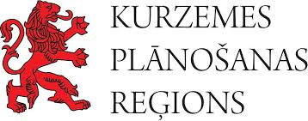  

Experience Exchange Visit Programme

Balts’ Road Semigallian and Selonian Route Segments

24.-25.09.2020

|  |  |
| --- | --- |
| 08:00 - boarding (bus at Saldus Market Square parking lot) | |
| Semigallian Route Segment | |
|  | 08:40 Dobe (Incēni) Hillfort |
|  | 09:40 Dobele Hillfort and Castle Ruins |
|  | 10:20 Dobele Local History Museum |
|  | 11:30 Dobele Crafts House, lunch |
|  | 13:30 Jelgava History and Art Museum of Ģ. Eliass |
|  | 15:30 Tērvete Wooden Castle of 12th century |
|  | 19:00 Dinner and resting time at Rancho Randevu |
| Selonian Route Segment | |
|  | 10:00 Creative House Baltaine – breakfast, Koknese Park and Castle Ruins |
|  | 12:30 Jēkabpils History Museum Open-air exhibition – Selonian farmstead |
|  | 14:00 Craft Centre Rūme – workshop on leather bracelets and lunch in Zasa |
|  | 17:00 Sēlpils Hillfort  Return in Saldus ~ 20:30 |

Experience exchange visit is organised by Kurzeme Planning Region with support from the Interreg Latvia-Lithuania Cross-Border Cooperation Programme 2014-2020 as part of the project Nr. LLI-447 “Exploring Balts and Promoting Awareness of the International Cultural Route “Balts’ Road” (Explore Balts).

Additional information: Alise Lūse, +371 26567874, [alise.luse@kurzemesregions.lv](mailto:alise.luse@kurzemesregions.lv)