Military Heritage in Lithuania and Poland
May 9-14, 2022
Programme 6 days
(accomodation, catering, entrances included) + bus provided

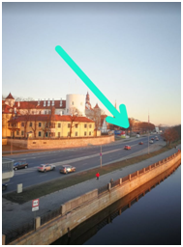
9th May
Day 1
14:00 | Departure from Riga, near Riga Castle (in picture)
18:00 | Arrival in Kaunas
Accommodation at Kaunas Hotel**** http://www.kaunashotel.lt/
1 Twin room (for drivers)
19:30 | Dinner at local food restaurant „Višta Puode“  http://vištapuode.lt (0,5 km from hotel)

10th May
Day 2 ~ 270 km by bus
Breakfast, 8:45 departure
09:30 - 11:00 | Kaunas, 9.th. fort and open air museum in Kaunas WWI, WWII, Soviet occupation. Meeting with Museum director and marketing department  https://www.9fortomuziejus.lt/?lang=en
12:00 – 13:00 | Along the route we will do it at 12.00 at https://www.grizuloratai.eu/?page_id=1675&lang=en lunch here
16:00 - 18:00 | Wolfsschanze, Hitler´s headquarter in Gierłoż, WWII https://wolfsschanze.pl/en/ Meeting representatives from Srokovo Forest Authority and Wolf’s Lair visitor centre
19:00 | Accommodation at Hotel Mazury *** https://hotelmazury.pl/  1 Twin room (for drivers)
19:30 | Dinner at Hotel Mazury

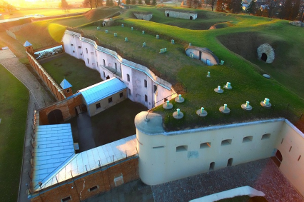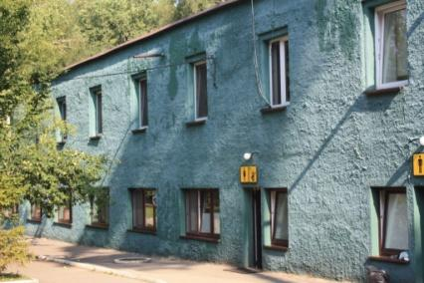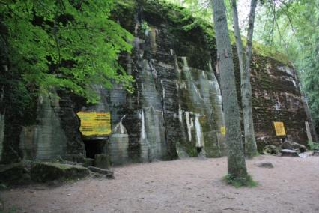
Photos: 9.th. fort at Kaunas, Hotel at Wolfschanze, Hitler’s bunker in Wolfschanze

May 11th
Day 3 ~ 260 km by bus to Gdansk
Breakfast, 8:45 departure
13:00 - 14:00 | Lunch at Vidok Restaurant at WW2 museum https://muzeum1939.pl/en/restaurants.html
14:00 - 15:00 | Meeting museum Director and International relation department as well as history specialists  https://muzeum1939.pl/en/team.html
15:00 – 16:00 | Guided Tour of Museum https://muzeum1939.pl/en
16:30 - 18:30 | Westerplatte, last place German troops invaded in 1939, IIWW, evening hike (2-3 km)  https://www.inyourpocket.com/gdansk/westerplatte-where-wwii-began_73617f
Accommodation Hamptom by Hilton Gdansk Old Town Hotel for 2 nights https://www.hilton.com/en/hotels/gdnhxhx-hampton-gdansk-old-town/?WT.mc_id=zVSEC0PL1HP2NaturalSearch3GoogleMyBusiness4luau-goldtown_Jul5luau6GDNHXHX7EN8i1
1 Twin room (for drivers)
19:30 | Dinner at the Restaurant „Chleb I Wino“ www.chlebiwino.eu (appr. 0,7 km from the hotel)
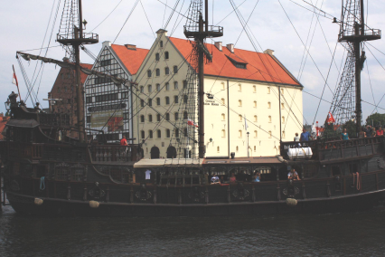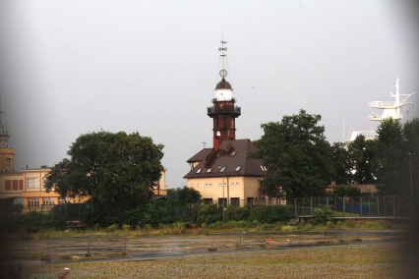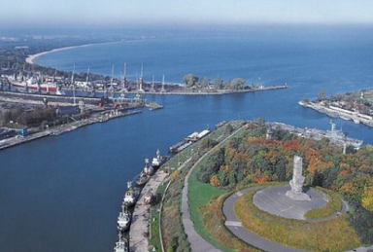
Photos: Gdansk Maritime museum, Westerplatte

May 12
Day 4 ~ 350 km by bus
Breakfast, 8:45 departure
11:00 - 12:00 | Muzeum Obrony Wybrzeża (Coastal defence museum) and “Schleswig - Holstein baterie), Director of the Museum will personally meet the group. https://helmuzeum.pl/pl/museum/history
12:00 - 13:00 | Small walk through the forest and visiting of Fire Control Tower, https://tropter.com/en/poland/hel/fire-control-tower-museum
13:00 - 14:00 | Lunch at the restaurant „Kutter“ in Hel http://www.kutter.pl/
16:00 - 18:00 | Muzeum Wyrzutnia Rakiet (Rocket Launcher museum) - 3x2 km hike till museum through the Slowinski Nature park  https://its-poland.com/attraction/rocket-launcher-museum-in-rabka
Accommodation Hampton by Hilton Gdansk Old Town
19:00 | Dinner at Restaurant Piwnica Rajców  https://piwnicarajcowgdansk.pl/

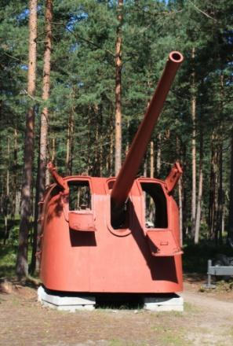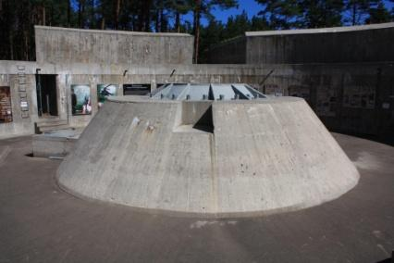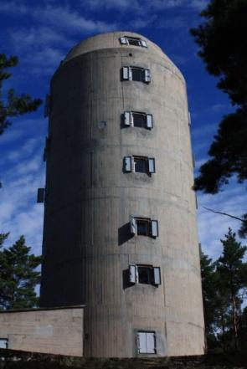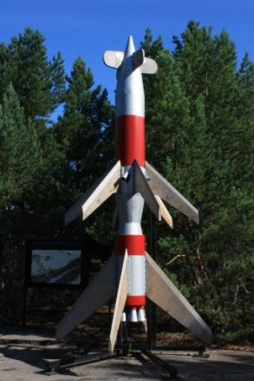
Photos: Coastal defence museum, Fire Control Tower, Rocket Launcher museum

May 13
Day 5 ~ 560 km
Breakfast, 8:00 departure
13:30 - 14:30 | Lunch at Narrow Gauge Railway
14:30 – 15:00 | Meeting with Wigry Nature park and Narrow Gauge railway representatives
15:00 - 17:00 | Forest Narrow gauge railway ride (Wigierska Kolej Wąskotorowa)  from WW1 - main attraction of the Suwalki region and Wigierski Nature park (train ride and/or meeting with local authorities)  https://pl.wikipedia.org/wiki/Wigierska_Kolej_W%C4%85skotorowa
Accommodation at Kaunas Hotel http://www.kaunashotel.lt/
1 Twin room (for drivers)
20:30 | Dinner at Restaurant „Donelaicio“ https://visit.kaunas.lt/lt/paragaukite/restoranai/siandienai/donelaicio/
Evening hike in Kaunas old city
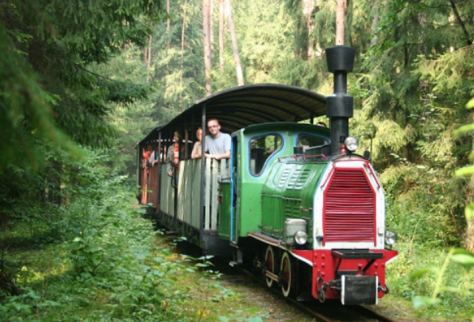
Photo: Wigierska Kolej Wąskotorowa

May 14
Day 6 (Kaunas - Riga - 280 km, Kaunas - Parnu - 460 km)
Breakfast, 8:00 departure
12:30 | Rīga

Tour map: https://www.google.com/maps/d/edit?hl=en&hl=en&mid=1x-xh2f5CN-PmDF037paJG-v0ga00RCLA&ll=56.82083044571286%2C24.6031895&z=7

Juris Smalinskis photo gallery of Poland military objects: https://galerija.celotajs.lv/lv/f/Events/2022/220110_Military_heritage_Poland

This project is co-financed by the Estonian-Latvian cross-border cooperation program of the objective "European Territorial Cooperation" of the European Structural and Investment Funds.
This information reflects the views of the author. The managing authority of the programme is not liable for how this information may be used.

